**WRS – document for NavCampus**

**Team Members:**

* Nico Kopitza - *Project Lead*
* Chan Rain, Alessandro Valenti - *Developer*

Phase 1: Finished (October 23, 2023)

Phase 2: In progress

Team website - github.com/chanra1n/navcampus

Revision History:

|  |  |  |
| --- | --- | --- |
| **Version** | **Date** | **Author** |
| 0.8 | Oct. 16 2023 | Nico Kopitza |
| 0.9 | Oct 20, 2023 | Chan Rain |
| 1.0 | Oct 23, 2023 | Nico Kopitza |
| 1.1 | Nov 20, 2023 | Nico Kopitza |
| 1.2 | Dec 01, 2023 | Nico Kopitza |

**Table of Contents:**

1. Introduction p.3

1.1 Introduction p.3

1.2 Purpose p.3

1.3 Scope of the system p.3

1.4 Objectives p.3

2. Current system p.3

3. Issues with the preliminary definition p.3

3.1 Issues with the real-world p.3

3.2 Functional objectives p.6

3.3 Non-functional objectives p.7

4. Improved understanding p.9

4.1 W p.9

4.1.1 Problem p.9

4.1.2 Goal p.9

4.1.3 Improved Understanding of domain, stakeholders and the (non-)-

functional objectives p.9

4.2 RS p.10

4.2.1 Functional requirements p.10

4.2.2 Non-functional requirements p.11

5. Preliminary Prototype and User Manual p.12

6. Traceability p.12

7. References p.14

**1. Introduction:**

* 1. **Introduction**

“NavCampus” is a web app that supports blind people in navigating on campus, especially in buildings. The system will make use of an internal three-dimensional map of the buildings. On multiple locations there will be signs to give the app the user's location. The GPS system will provide the direction the user looks, so that the system can provide the way the user needs to go to a desired room; as well as an estimated number of steps they need to take. Also, it provides an object identification system.

* 1. **Purpose**

The main goal of this project is to create an easy to access navigation program for visually impaired students, helping them find their classrooms and avoid obstacles.

* 1. **Scope of the System**

The scope of this system starts from the moment the user specifies their location up to their arrival at the desired location. This App includes the Theatre Arts Building of the Cal Poly Humboldt Campus. The Prototype will only consist of the UI for the App.

* 1. **Objectives**

The App will provide safe navigation to a desired place in the building for visually impaired persons.

**2. Current System**

At the moment there is no comparable system installed on the campus. Blind people are dependent on their own navigation skills as well as the guidance of other people. So, it is a manual trial and error process until the person knows their way around campus.

**3. Issues with Preliminary**

**3.1 Issues within the real world:**

**3.1.1** *Domain issue – Indoor mapping*

* Indoor mappings can change over time, like the position of furniture or the numbering system for the rooms. Because of that it is hard to maintain current and accurate data about the mapping.
* *Options*: crowd sourced information, staff member, a system that includes the app in the official bureaucracy of the university regarding furniture and layout, map editing feature for university.
* *Decision:* There should be close communication between the team and the university and bigger moved objects should be noticed to the developers, so that the apps can be regularly updated.

**3.1.2** *Domain issue – object detection*

* The app needs to be able to detect objects that are in the way of the user. But this is difficult to achieve. Since the position of objects can alter and exact measurements of distance are hard to achieve. Also detecting all types of objects, for example furniture or people are hard to differentiate and detect.
* *Options:* The options here are machine learning approaches that learn to identify people and objects and their distance. This could be achieved with the help of modern smartphone cameras. Another way is to let the blind person still use a cane while using the system, so they don't collide with anything.
* *Decision:* For safety reasons a mixed approach is best. There should be a machine learning system to identify faraway objects, but it cannot be compromised to use a cane for a second support system.

**3.1.3** *Domain issue – privacy concerns regarding staff and students*

* To achieve the goals of the app a camera-based detection cannot be avoided. But this means that surrounding persons are filmed while using the app without permission. This is prone to privacy complaints because people could be uncomfortable being filmed.
* *Options:* The three most achievable options here are:

1. That the consent to take pictures and videos is given by enrolling in the university or working for the university.
2. To encrypt all transmitted data to the server, so that no one can read it.
3. That the system does not collect any data.

* *Decision:* The best way for this system is to get the consent from all students and encrypt all data. Signage could also be posted by all entrances and exits. The system needs the data to fill the machine learning algorithms to provide the intended services.

**3.1.4** *Stakeholder issue – Accessibility advocates*

* Different experts to the matter may file complaints about what are the most critical features that are needed for blind staff and students. This could lead to a case in which the app cannot be used because some say that it is unsafe.
* *Options:* The options are to collaborate with the advocates or prioritize the safety and usability of the system.
* *Decision:* In this case both must be done to make the app legal. Also, the insight of a domain expert for this matter, would help finding more safety requirements (but isn't necessary in case of the prototype).

**3.1.5** *Stakeholder issue – Building owners/University*

* In case of actual use, it could be difficult to get permission to use the maps and data of the buildings. Making the maps ourselves would consume a lot of time and would probably require an expert or special equipment to get exact measurements.
* *Options:* There is the possibility to get the maps from the university or to make the maps ourselves.
* *Decision:* It is more feasible to get the maps from the university, because the Team doesn't have the equipment to measure in a precise enough way to guarantee safety.

**3.1.6** *Stakeholder issue – User feedback of the visually impaired*

* This could be difficult to process since everyone has a difference in preference on how to use their mobile device and what type of assistance they need.
* *Options:* This can be achieved by incorporating multiple feedback channels, seeking evaluation from advocates, or using an AI for a comprehensive assessment of the wishes.
* *Decision:* Because the number of blind people and experts on that matter is relatively small, multiple feedback channels in front of a forum or a social media page satisfy the needs.

**3.1.7** *Stakeholder issue – User differences*

* There are a lot of different types of blindness. Some just see bad, some have fragments in their sight, some perceive colors differently, and others cannot see anything at all. The app would need to cater all those different needs. This would require taking personal information about what type they are and would take a lot of resources.
* *Options:* There is the option to create a version for every kind of blindness and make the app adjustable. The other option is to create one version for everybody that is based on the needs of completely blind persons.
* *Decision:* In this project it is the best possible solution to just create just one version of the app because of the limited time and the lack of time and resources.

**3.1.8** *Stakeholder issue – challenges with being blind*

* The users have difficulties finding their way around because they cannot interact with the visual designs for navigation. Therefore, they often don't know where they are exactly. The hard terrain on the campus, that is due to being built on a hill further makes it hard to find out on which floor you came in.
* *Options:* One way would be to put identifiers on the door of every building so the app can notice these. A sign with braille would generally also be a good idea.
* *Decision:* For the sake of the app an identifier works best, because it makes it easier to locate the exact location.

**3.1.9** *Functional requirement issue – Safety*

* The app needs to be safe to use. That means the user can depend on the accurate functioning of it, so that no accidents happen that were caused by the app itself. Examples include, that the app doesn't tell the user about an object and the user falls because of it, which could lead to injuries or the inability to orient themselves. Also, it should be able to guide a safe route.
* *Options:* walk with cane -> two systems, fall sensor, so that the phone can call for help in case of emergency
* *Decision:* There is no guarantee for safety when not using the cane at the same time and a fall sensor will be implemented that can call for help.

**3.1.10** *Stakeholder issue – Group size*

* The project group only consists of 3 people. This lack of manpower creates a problem in being able to deliver on time.
* *Options:* The team needs to plan accordingly and use their time efficiently.
* *Decision:* Just give our best in an organized and efficient way.

**3.2 Functional objectives**

**3.2.1** *Functional objective issue – Indoor position detection*

* It is hard to detect an exact position inside a building. On campus most buildings have multiple floors and therefore there is a z-axis for the position which makes finding the exact position even more complex. This is a problem that needs to be solved, because without that it is not possible to guarantee accurate mapping.
* *Options:* There are various options for this. There is the possibility to use GPS, but it isn't as precise as it would be necessary for the system. Also, there are various systems that measure the distance of the device to access point, which (in most cases) make use of the device’s Wi-Fi connection. But since a Wi-Fi connection isn't available everywhere on campus and it would need to be a good signal everywhere it would take bigger investments to realize such an approach. Another approach is a technology that can detect your location based on a picture that can be connected to an accurate three-dimensional map. This approach was first made by “Genius Matcher” for navigation in malls in Israel.
* *Decision:* A combination between the 3D map and an GPS based system because the map must be made in every case. The start location could be based on the room signs. So there only needs to be signs added on the entrances.

**3.2.2** *Functional objective issue – real time object detection*

* In the best case the position of furniture is already part of the mapping. But keeping up with changes takes a lot of resources from one side or the other. (Team side or university staff)
* *Options:* collaboration with University staff (see 3.1.1)
* *Decision:* There should be a new form be filled in with the university when big furniture gets moved, so that the maps can be updated

**3.2.3** *Functional objective issue – processing of real time data of the camera*

* The app needs to be able to detect objects with the camera and give some kind of warning depending on location and distance.
* *Options:* The only real option here is using some kind of machine learning approach. The notification can be directed to the user as well as their surroundings.
* *Decision:* The app will use a machine learning approach to detect objects in real time using the camera of the device. The message will be directed at the user. When the user doesn’t use headphones their surroundings will also be able to hear the alert.

**3.2.4** *Functional objective issue – cross-platform compatibility*

* The app needs to be able to run stable on a multitude of devices and operating systems. This takes extra resources and time.
* *Options:* Coordinating all possible operating systems and the same time which takes time and a lot of resources. Prioritizing one operating system with a phased approach afterwards which makes the app unavailable for some possible users. Using a web app approach.
* *Decision:* With our current group size, a web app approach will have to be used. This ensures that all operating systems (at least those with a web browser) will be able to use this app.

**3.2.5** *User accessibility*

* The app is to be designed for visually impaired students. Therefore, the app can’t only be operated by normal means. This means it needs to be usable without seeing the actual display of the smartphone.
* *Options:* voice commands and audio-based navigation, special blind keyboard, compatibility with screen readers and accessibility features
* *Decision:* audio-based navigation, voice commands.

**3.2.6** *Functional objective issue – tracking walked distance*

* The app needs a way to track the distance the user has walked in a direction to calculate the new location.
* *Options:* The system can use the device sensors like the camera or the step count and step distance as well as the GPS. The system could provide a manual step tracker which activates on touch for example.
* *Decision:* Using the device sensors is the best option here, because this information is already available.

**3.3 Non-functional objectives**

**3.3.1** *Non-functional objective issue – Performance*

* The app handling real-time data means that it could be hardware heavy and could lead to performance issues on hardware-weaker devices. This could lead to failure to assist the user or even could lead to safety issues when the user cannot be notified about obstacles.
* *Options:* optimize algorithm for minimal resource consumption, minimum hardware requirements
* *Decision:* Because of the lack of resources there will be hardware requirements. Even so, the optimization would be the better option to help as many students/staff members as possible even when they don't have the financial ability to pay for the newer devices.

**3.3.2** *Non-functional objective issue – Battery life*

* The use of real time detection could lead to increased battery drain. That could lead to inconveniences on the user side because the battery of the device could go empty. This would make their life harder instead of easier.
* *Options:* implement power saving mode (technically we don't need the display on), guidelines.
* *Decision:* Power saving modes because the app shouldn't be complicated to use. Since blind people don't need to look at the screen, it doesn’t actually need to show anything during navigation, which saves a lot of energy. Also, using black and white as the main colors of the interface could help save power.

**3.3.3** *Non-functional objective issue - Data security*

* Data security is key when working with camera detection and the collection of the location data of the users.
* *Options:* implement data encryption and data protection vaults, update security protocols, saving as less data as possible
* *Decision:* Because the data is needed for the machine learning to function there needs to be data encryption and the data is only to be seen by the system itself.

**3.3.4** *Prioritization – Privacy and functionality*

* Balancing the need for personal data in forms of camera detection, location data, and privacy concerns can be challenging.
* *Options:* consent of all students by enrollment, disabling screenshots, no data collection
* *Decision:* The implementation of the first two options because these are feasible, while the last one is needed for functioning and therefore cannot be compromised.

**3.3.5** *Prioritization – Accuracy and speed*

* There needs to be a compromise on how fast the app can detect the location and identify objects in regards to how accurate the measurements are.
* *Options:* Safety is our biggest concern, so accuracy is more important and shall be the prioritization
* *Decision:* Prioritization of accuracy for safety reasons.

**3.3.6** *Lawfulness*

* There are a lot of privacy laws in the US/California. The app needs to follow all of them and the local laws.
* *Options:* Informing ourselves is not feasible and not safe enough. There is the possibility to discuss matters with experts and the university.
* *Decision:* The implementation of the second option.

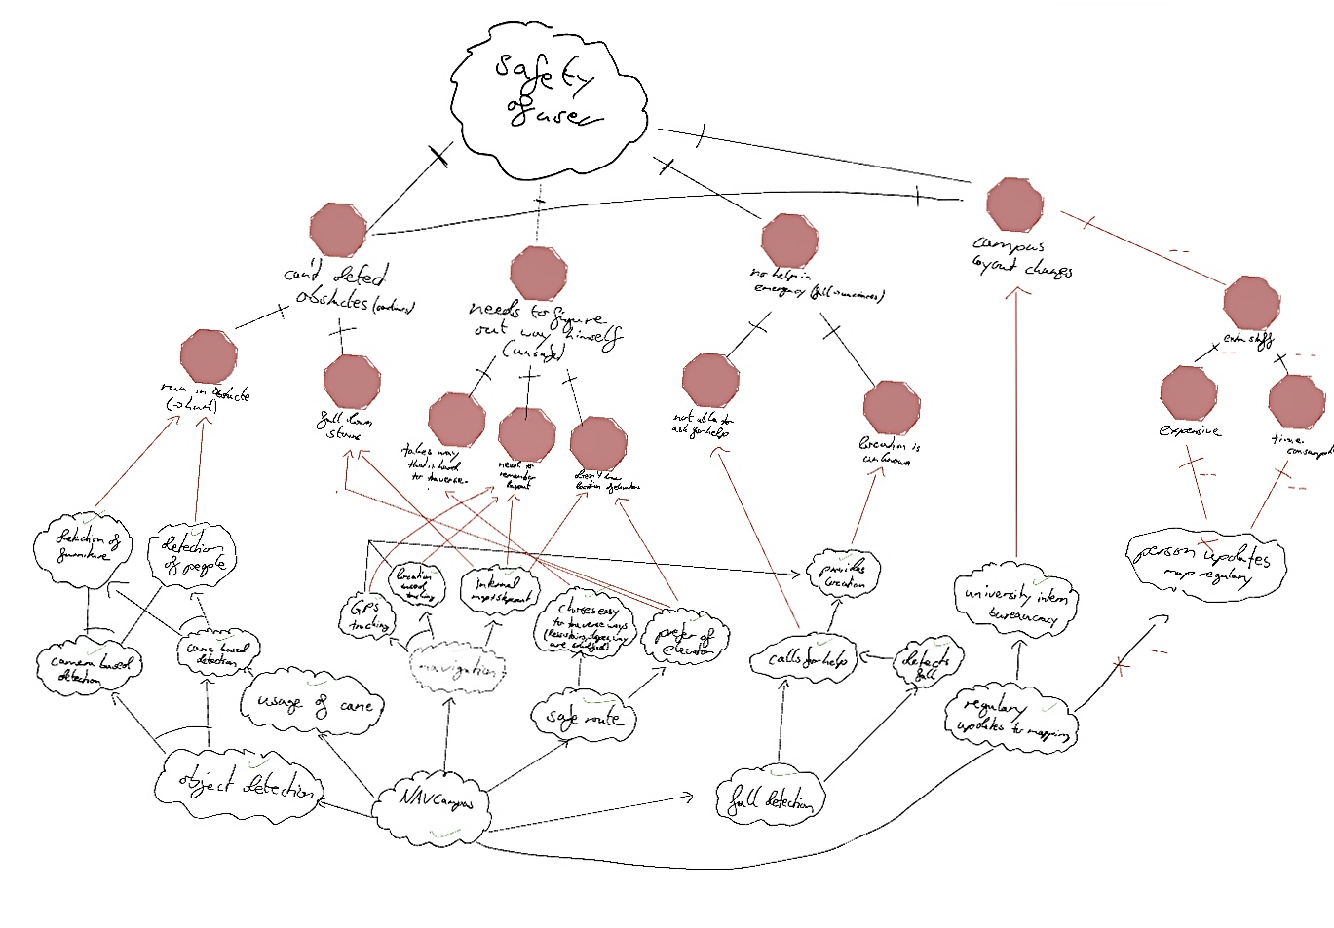

**4. Improved understanding**

**4.1 W**

**4.1.1 Problem**

Visually impaired people have problems navigating the world around them. These are subjective issues for everyone. So, it is hard to find common ground on what is needed to help them in their everyday life. This is especially true when they are in a new space because they don't know the area, but also can't use maps. While there are possible solutions most of them aren’t as accurate and precise for specific areas and indoor areas.

**4.1.2 Goal**

The team’s goal is to create an application for mobile devices that gives blind people an audio-accessible navigation method; that helps them find their classrooms in the university’s buildings. The application will be easy to use and have multiple ways to interact with it.

**4.1.3 Improved Understanding of domain, stakeholders and the (Non-)functional objectives**

1. The App will be used by visually impaired people of all ages and all kinds of severity. Severity can reach from completely blind people to people with fragmented sight or blind spots, or those who perceive colors differently.
2. The “NavCampus” App shall provide navigation on the Cal Poly Humboldt campus buildings. For the prototype, only the Theatre Arts building will be included.
3. To have a second safety net the users still need to use their cane while using the app.
4. The users should tell the app where they want to go by providing a building and a room number or name.
5. The system shall allow the user to navigate without seeing the screen.
6. The interface of the app shall be high contrast so that some users can still use the interface.
7. The system shall give a way to provide feedback.
8. The system shall provide a way to input navigation data in an audible as well as a typing way.
9. The system shall use the following sensors to detect location and movement.

1. GPS

2. Camera

3. Step counter

4. fall sensor

1. The app shall have a way to detect objects that would be in the way of the user using machine learning and the camera sensor.
2. The system shall have a fall detection.
3. The system shall be able to call for help in case of falling and not reacting.
4. The system shall prioritize safety as its number one objective.
5. The system shall provide safe navigation that prioritizes elevators over stairs.
6. The system shall encrypt all data that is transmitted.
7. The user shall be notified where they are after the location is determined.
8. The user shall be easily able to use the app.

**4.2 RS**

**4.2.1 Functional Requirements**

(RA) UI

RA1: The app shall have a voice input feature, to give it the desired location.  
RA2: The app shall have the possibility to turn in a dark mode during navigation to save battery when the user chooses this option. In this mode, the screen is dark and activates again when tapping it.

The User shall be able to activate this setting with a voice command.

RA3: The app shall instruct the user how to use it with audio lines.

RA4: The app shall give the navigation data via audio.

RA5: The app shall show the next navigation in the form of an arrow and the needed steps until then.

The Arrow will point to the direction of navigation.

RA6: The voice command shall end if the user taps the screen.

RA7: When using the voice command, the system shall notify the user after 30 seconds of inactivity to tap the screen to end the voice command.

RA8: After the voice command the system shall tell the user the chosen location for navigation.

(RB) Mapping

RB1: there shall be an internal map of the buildings, not shown to the user. These maps shall include:

1. room location

2. entrance location

3. bigger furniture location

RB2: Every location (entrances, rooms) shall have a unique identifier in the form of a picture.

(RC) Navigation

RC1: There shall be a unique identifier on each door or entrance (Building name + room number/ Building name + floor)

RC2: The app shall prioritize elevators over stairs during navigation.

RC3: The system shall take the GPS to detect the direction the user is phasing and in which direction he/she/they are moving.

RC4: The app shall find the safest way to the desired location based on the map.

RC5: the system shall use the collected health data of the phone to get the average step length of the user.

RC6: The step count shall be used to calculate how many steps are needed to reach the next turn point.

RC7: The user shall be able to stop the navigation.

RC8: Hallways that are hard to traverse shall be marked on the internal map.

RC9: Hard to traverse shall be avoided if possible.

(RD) Object detection + notification

RD1: The app shall detect the identifier and be able to tell where on the map the user is.

RD2: The system shall take the GPS to detect the direction the user is phasing and in which direction he/she/they are moving.

RD3: The system shall detect objects that are in the way of the user, excluding the cane.

RD4: The system shall have a machine learning algorithm to learn to detect objects and the distance to the user, using the camera of the device.

RD5: The system shall notify the user where the object is with an audio line and on the screen.

(RE) emergency call + fall detection

RE1: The fall sensor shall be activated throughout the use of the app.

RE2: In case of a fall a countdown shall be activated.

1. The countdown is 30 sec long.
2. During the countdown the app uses audio lines to get the user to tap three times in rapid succession (“triple tap”) on the screen.
3. The countdown deactivates after a triple tap.

RE3: In case that the countdown is not deactivated, the system shall call the university police department to get help.

RE4: The system shall provide the UPD with the current GPS location, as well as the set destination in case of the emergency call.

(RF) User feedback

RF1: The user shall be able to give feedback inside the app through a direct message.

1. When the device detects a “triple tap”, and the app is not in fall detection mode, the user feedback interface shall open.

2. The app will begin recording. The user can state their issues/feedback, and tap the screen to end recording.

3. The app saves this recording as an audio file, and sends this file directly to the developer’s email address.

(RG) Other

RG1: The app shall tell the user to continue using the cane at the beginning of usage if they usually use one.

RG2: The system shall have access to the devices sensors: camera, GPS, step count and the step measurement.

**4.2.2 Non-functional Requirements**

NR1: The system shall be usable without the need to see.

1. The system shall provide audio lines for every instruction.
2. The system shall allow text to speech systems.
3. The app shall use high contrast colors.

NR2: The system shall provide a good steady performance.

1. The system may be optimized for newer devices.
2. The system shall first be optimized for one system.

NR3: The system shall not use too much battery.

1. see RA2
2. see NR2.2

NR4: The system shall keep collected data safe.

1. The system shall strongly encrypt all data.
2. The app shall block screenshots.
3. The collected data shall not be saved on the device of the user.

NR5: The system's main concern shall be safety.

1. The user shall use the cane while usage, when the user normally uses one. RG1

2. The system shall have a fall detector by using the device's sensors.

3. The system shall take the safest route. RC 2 + 4

4. The safest route is determined by avoiding hard to traverse routes and stairs.

5. "Hard to traverse” is defined as environments posing significant obstacles, impeding smooth navigation.

NR6: The system shall follow all laws.

1. All employees that work on the app shall get HIPAA training.
2. The app shall have role-based access.
3. The university shall provide a way to get consent from all students and all staff.
4. The system shall be insured against errors and following accidents.
5. The data collection shall be in line with the CCPA and the CalOPPA.
6. The app shall be tested by the advocates to ensure that the requirements are fulfilled.

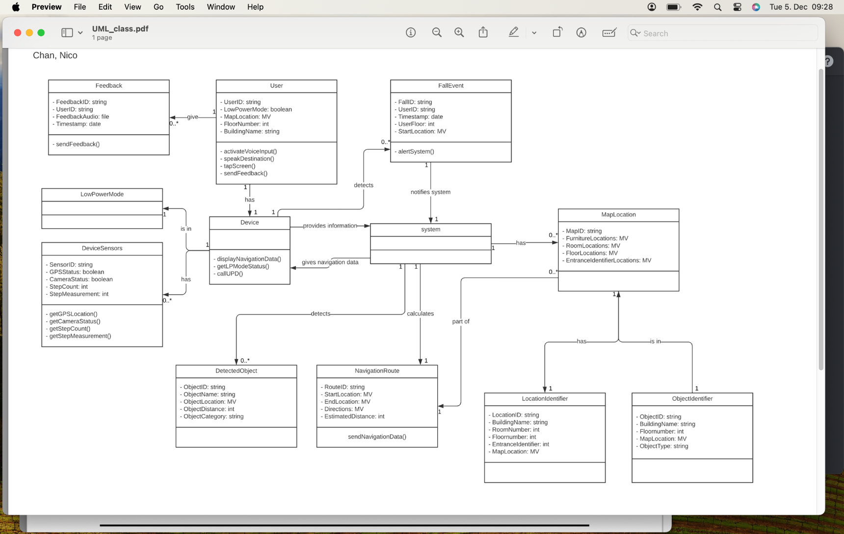

**5. Preliminary Prototype and User Manual**

Both documents will be provided as an attachment to this documentation.

**6. Traceability**

|  |  |  |
| --- | --- | --- |
| **Requirement ID** | **Issue ID** | **Vision ID** |
| A | 3.1.7 | 5.1, 5.7 |
| B | 3.1.5 | 5.1, 5.8 |
| C | 3.1.2, 3.1.9 |  |
| D | 3.1.1, 3.2.1 | 5.4 |
| E | 3.2.5 | 5.1, 5.4 |
| F | 3.2.5 | 5.7 |
| G | 3.1.6 | 5.6 |
| H | 3.2.5 | 5.4, 5.8 |
| I | 3.2.1, 3.2.2, 3.1.2, 3.1.9 | 5.1, 5.2, 5.3 |
| J | 3.2.2 | 5.2, 5.10 |
| K | 3.1.9 | 5.3 |
| L | 3.1.9 | 5.3 |
| M | 3.1.9 | 5.3, 5.5 |
| N | 3.2.1 | 5.5 |
| O | 3.1.3, 3.3.3 | 5.9 |
| P | 3.2.1 | 5.1 |
| Q | 3.2.5 | 5.1, 5.4 |
| RA1 | 3.1.7 | 5.4 |
| RA2 | 3.2.5 |  |
| RA3 | 3.2.5 | 5.4, 5.5 |
| RA4 | 3.2.5 | 5.4 |
| RA5 | 3.2.5, Q | 5.1 |
| RA6 | 3.2.5 | 5.4 |
| RA7 | 3.2.5 | 5.4 |
| RA8 | 3.2.5 | 5.4 |
| RB1 | 3.1.1 | 5.1, 5.8 |
| RB2 | 3.1.1 | 5.8 |
| RC1 | 3.2.1 | 5.8 |
| RC2 | 3.1.8, 3.3.5 | 5.5 |
| RC3 | 3.2.1 | 5.1, 5.2 |
| RC4 | 3.2.1, 3.3.5 | 5.5 |
| RC5 | 3.2.6 | 5.5 |
| RC6 | 3.2.6 | 5.5 |
| RC7 | 3.2.6 | 5.1 |
| RC8 | 3.2.1, 3.3.5 | 5.5 |
| RC9 | 3.2.1, 3.3.5 | 5.5 |
| RD1 | 3.2.2 | 5.2, 5.8 |
| RD2 | 3.2.2 | 5.1, 5.2 |
| RD3 | 3.1.2, 3.2.2 | 5.2 |
| RD4 | 3.1.2, 3.2.2, 3.2.3 | 5.10 |
| RD5 | 3.1.8, 3.2.5 | 5.2, 5.4 |
| RE1 | 3.1.9 | 5.3 |
| RE2 | 3.1.9 | 5.3 |
| RE3 | 3.1.9 | 5.3 |
| RE4 | 3.1.9 | 5.3 |
| RF | 3.1.6 | 5.6 |
| RG1 | 3.1.8 |  |
| RG2 | 3.2.1, 3.2.6, 3.2.3 | 5.1, 5.2, 5.5 |
| NR1.1 | 3.2.5 | 5.4 |
| NR1.2 | 3.1.8, 3.1.7 | 5.4 |
| NR1.3 | 3.1.8, 3.1.7 | 5.7 |
| NR2.1 | 3.3.1, 3.2.4 | 5.2 |
| NR2.2 | 3.2.4 | 5.2 |
| NR3.1 | 3.1.7, 3.3.2 | 5.4 |
| NR3.2 | 3.1.7, 3.3.2 | 5.2, 5.10 |
| NR4.1 | 3.1.3, 3.3.4 | 5.9 |
| NR4.2 | 3.1.3, 3.3.4 |  |
| NR4.3 | 3.1.3 | 5.9 |
| NR5.1 | 3.1.9 | 5.3 |
| NR5.2 | 3.1.9 | 5.3 |
| NR5.3 | 3.1.9 | 5.5 |
| NR6.1 | 3.3.6 |  |
| NR6.2 | 3.3.3 |  |
| NR6.3 | 3.3.3, 3.3.4, 3.3.6 | 5.6 |
| NR6.4 | 3.3.6 | 5.3 |
| NR6.5 | 3.3.6 | 5.9 |
| NR6.6 | 3.1.4 | 5.6 |

1. **References**

(1) Preliminary document of the group

(2) Project Phase I: Requirements Elicitation: Initial Understanding

(3) https://en.wikipedia.org/wiki/Geniusmatcher accessed on oct.1 2023

(4) <https://en.wikipedia.org/wiki/Visual_impairment> accessed on sep.19 2023

(5) <https://oag.ca.gov/privacy/ccpa> accessed on sep. 19 2023

(6) <https://consumercal.org/about-cfc/cfc-education-foundation/california-online-privacy-protection-act-caloppa-3/> accessed on oct. 20 2023

(7) <https://www.hhs.gov/hipaa/index.html> accessed on oct. 20 2023

(8) Vision document of Team NavCampus